TRAUMATIC RETICULOPERITONITIS:
Perforation of the wall of the reticulum by a sharp foreign body initially produces an acute local peritonitis, which may spread to cause acute diffuse peritonitis or remain localized to cause subsequent damage, including vagal indigestion and diaphragmatic hernia.
Sequelae of the penetrating foreign body may proceed beyond the peritoneum and cause involvement of other organs resulting in:
- pericarditis,
- cardiac tamponade
- pneumonia
- pleurisy and mediastinitis
- hepatic, splenic or diaphragmatic abscess.
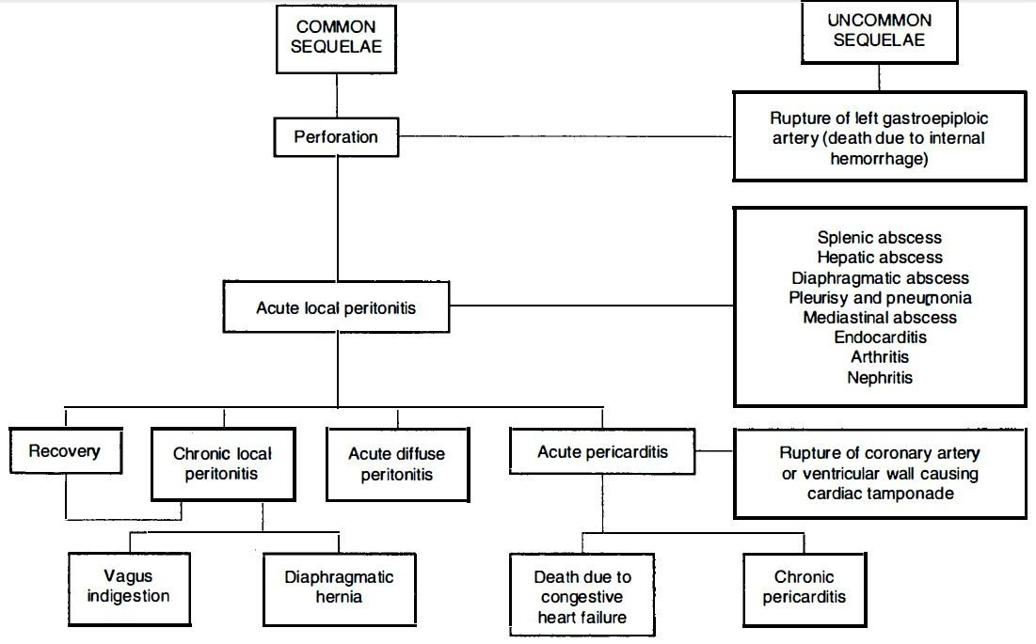
Sequelae of traumatic perforation of the reticular wall

Etiology and Epidemiology :
- Ingestion of metallic by the animal and located in the reticulum
- Penetration of reticulum by foreign objects such as nails and pieces of wire, including tire wire
- Adult dairy cattle are most commonly affected
- The incidence is low in sheep and goats. Pathogenesis:
- Lack of oral discrimination by cattle leads to the ingestion of foreign bodies that would be rejected by other species.
- Swallowed foreign bodies may lodge in the upper esophagus and cause obstruction
- or in the esophageal groove and cause vomiting
- in most instances they pass to the reticulum
- honeycomb-like structure of the reticulum provides many sites for fixation of the foreign body
- contractions of the reticulum are sufficient to push a sharp- pointed object through the wall
- acute local peritonitis
- fibrous adhesions
- motility of the reticulum is restored and the animal may recover fully
- reticulum becomes adherent to varying degrees to the abdominal floor and diaphragm this results in decreased reticular motility
- Persistent local peritonitis
- Spread of the inflammation causing generalized or diffuse peritonitis may occur in cows that calve at the time of perforation and in cattle that are forced to exercise

Clinical Findings:
1) acute local peritonitis:
- Sudden with complete anorexia and a marked drop in milk yield
- Subacute abdominal pain
- reluctant to move and does so slowly.
- Walking, particularly downhill, is often accompanied by grunting
- Arching of the back
- Defecation and urination cause pain
- A moderate systemic reaction is common
- Rumination is absent and reticulorumen movements are markedly depressed and usually absent
- Pain can be elicited by deep palpation of the abdominal wall just caudal to the xiphisternum
- Chronic local peritonitis
  - the appetite and milk yield do not return to normal after prolonged therapy with antimicrobials
  - The body condition is usually poor
  - the feces are reduced in quantity and there is an increase in undigested particles
- Acute diffuse (generalized) peritonitis:
  - profound toxemia within a day or two of the onset of local peritonitis
  - Alimentary tract motility is reduced
  - mental depression is marked t
  - he temperature is elevated or subnormal in severe cases
  - heart rate increases to 100-120/min

  - painful grunt may be elicited by deep digital palpation at almost any location over the ventral abdominal wall
  - recumbency and depression Clinical Pathology
- Hemogram:
  - In acute local peritonitis
    - a neutrophilia (mature neutrophils above 400/μL)
    - left shift (immature neutrophils above 200/μL) regenerative left shift
  - In acute diffuse peritonitis
    - aleukopenia (total count below 4000/μL)
    - with a greater absolute number of immature neutrophils than mature neutrophils (degenerative left shift)
  - Plasma protein and fibrinogen
  - Abdominocentesis and peritoneal fluid Other diagnosis methods:
- metal detection: ferrous metallic foreign bodies can be detected with metal detectors
- laparoscopy radiography of cranial abdomen and reticulum
- ultrasonography of the reticulum Necropsy findings:
A. Localized traumatic reticuloperitonitis is characterized by varying degrees of locally extensive fibrinous adhesions between the cranioventral aspects of the reticulum and the ventral abdominal wall and the diaphragm

Treatment
- Conservative medical therapy:
Antimicrobials: Penicillin or broad-spectrum antimicrobials given parenterally daily for 3-5 days
- Rumenotomy
- Drainage of reticular abscesses

VAGUS INDIGESTION:
Etiology:
  - complications of traumatic reticuloperitonitis:
    - vagal nerve injury
    - reticular adhesions Pathogenesis:
- dorsal vagal nerve injury
- achalasia of the reticulo-omasal orifice (anterior stenosis)
- inhibited the passage of ingesta from the reticulorumen into the omasum and abomasum
- distension of the rumen with pasty and/or frothy contents
- injury of the pyloric branch of the ventral vagus nerve resulted in achalasia of the pylorus (posterior stenosis) and inhibited the flow of ingesta from the abomasum resulting in abomasal impaction
- in reticular adhesions a mechanical impairment of reticular motility and esophageal groove dysfunction
Clinical Findings:
- Inappetence for several days or complete anorexia

- loss of body weight
- An enlarged 'papple' –shaped abdomen
- Dehydration and electrolyte imbalance with metabolic alkalosis
- Enlarged rumen palpable on rectal examination
- Scant feces with an increase in undigested particles
- Vital signs within the normal range
- Inadequate response to treatment Treatment:
- Rumen lavage
- Rumenotomy

